**Network Fundamentals Week 1 Log Book**

**Summary**

We learnt the basics of Riverbed and how to simulate a network by adding virtual machines, hubs, nodes etc. We had to send data across a network via nodes and a hub and then record the results of this data transfer.

**Implementation**

We used a program called Riverbed to simulate a network. We created a network with a series of nodes and a main hub. 1500 bytes of data was transferred across the network, we then recorded the results of the delay of transfer (via Ethernet) in seconds as well as the traffic received and the traffic sent. We also measured the delay for the hub and a series of nodes.

**Results**

Ethernet delay

The results show that the transfer delay for an Ethernet connection decreases over time and steadies at around 0.002. I assume this is due to the initial connection and transfer causing more of a load on the connection than when it is a constant flow of information.

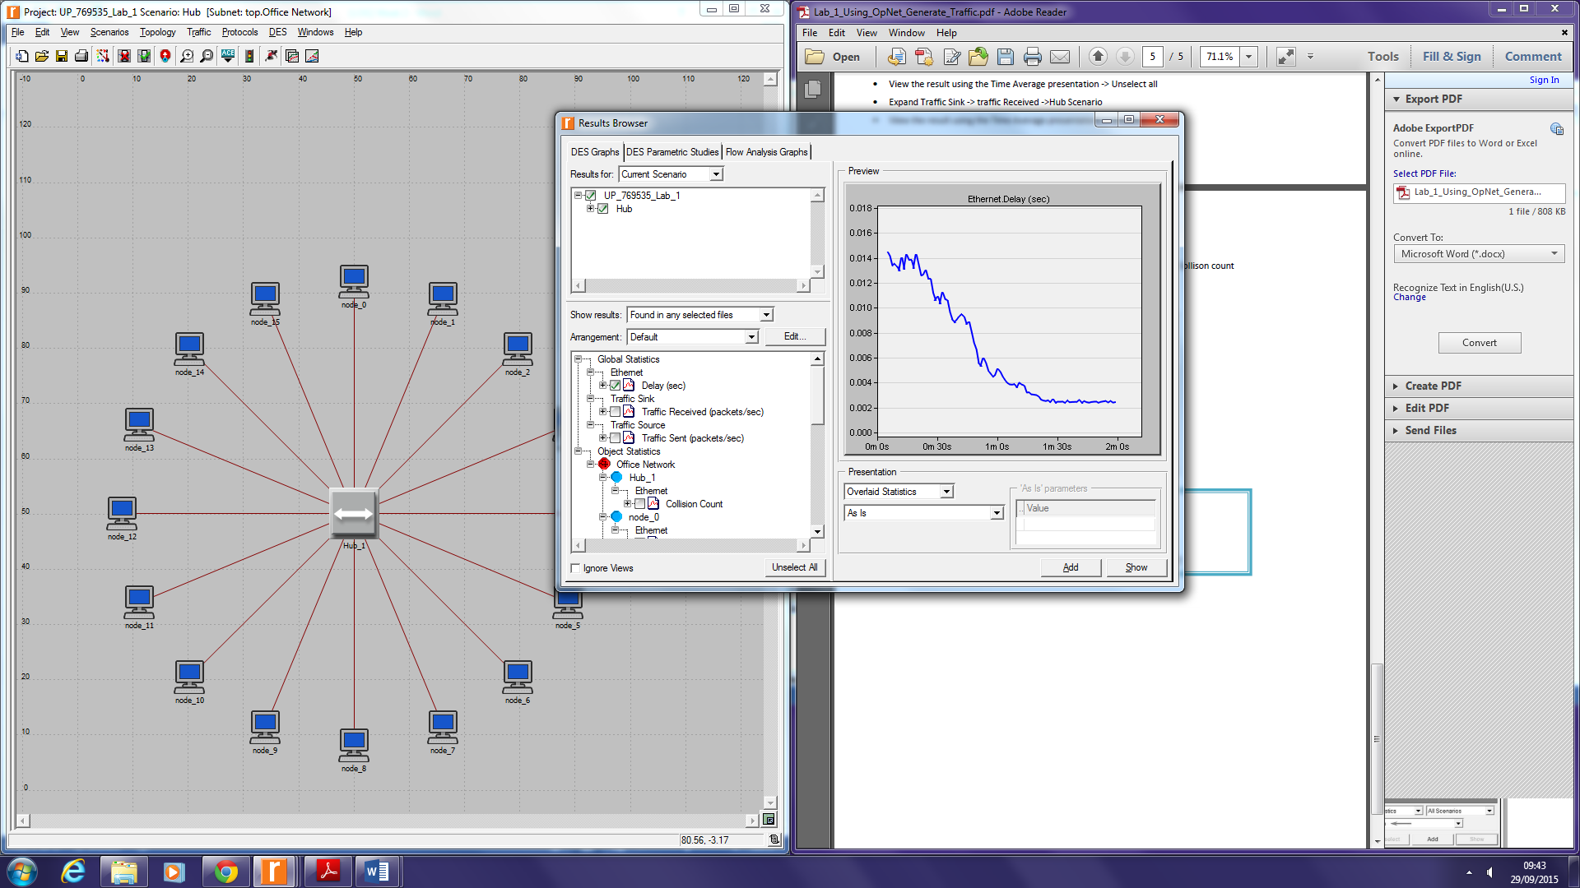

Traffic sent and traffic received

For some reason both the lines for sent and received are practically the same. I can only assume that because of the limited time period that there was little or no loss of information during up time.

*Edit: this is because I entered an incorrect value during setup*

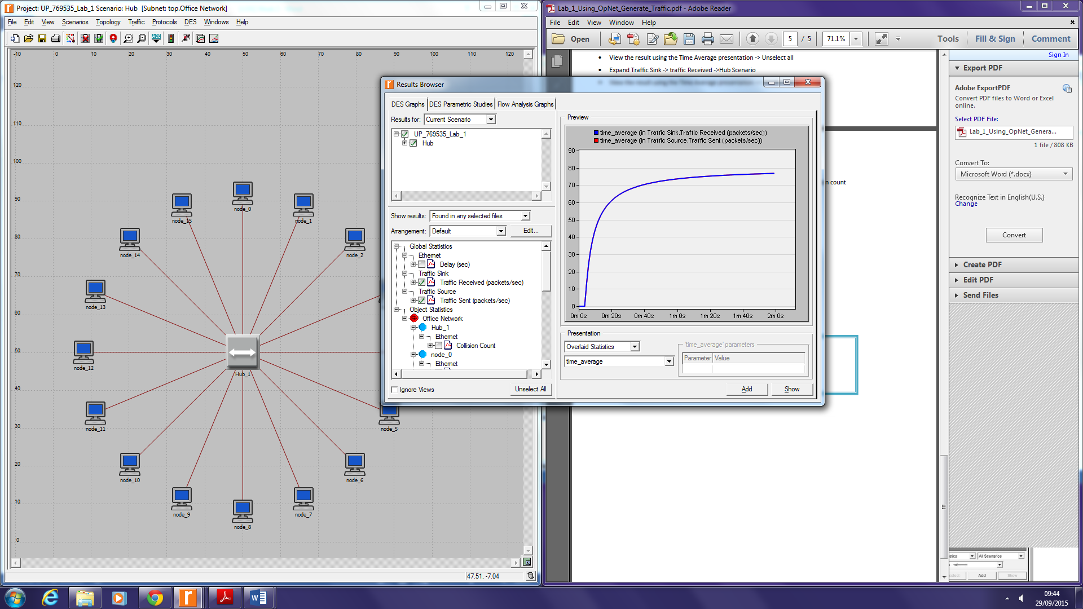

Hub delay vs node delay

From the graph below we can see that the hub has a lot more traffic than the nodes themselves, which of course is to be expected as the hub is handling all the information from all the nodes were as the nodes only handle the information for themselves.

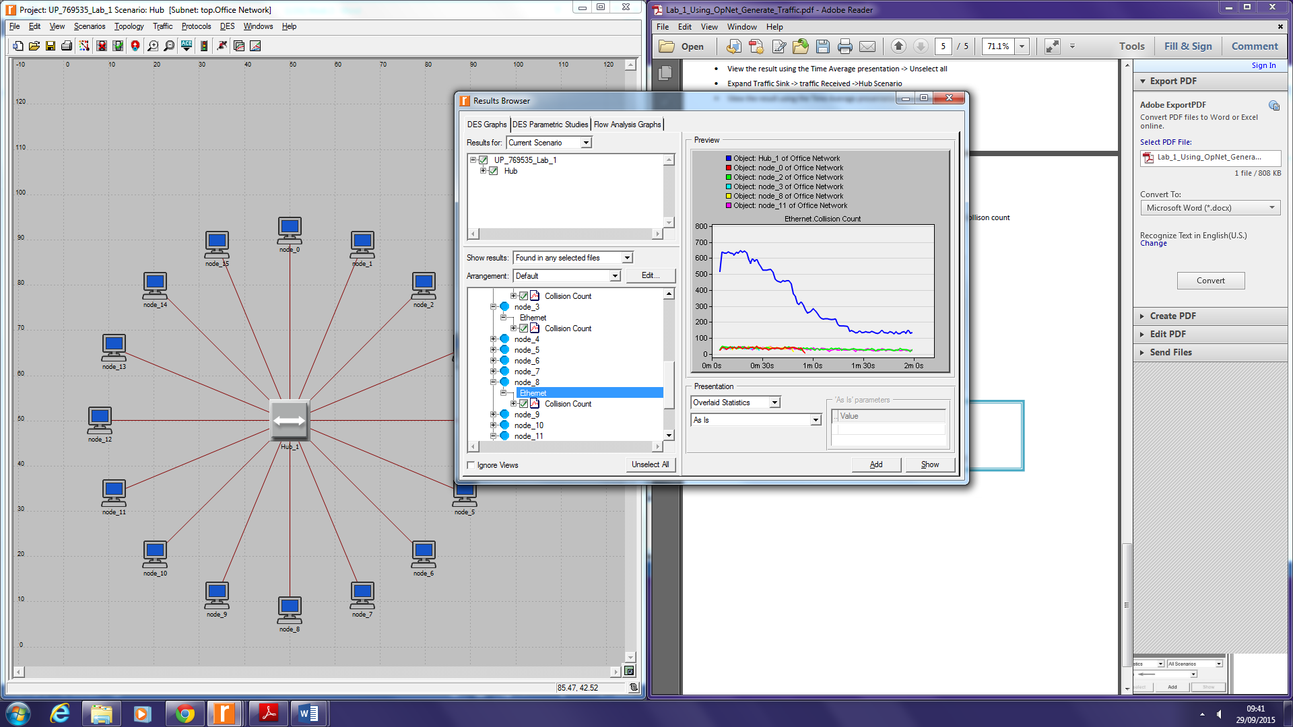

**Questions**

**Questions For your Lab books – Week Two**

1. How much traffic does each node generate?

A packet is sent every 0.02 seconds.

Therefore the number of packets sent every second is 50

Each packet is 1500 bytes big

Therefore, the traffic for each node is 75,000 bytes per second

1 byte = 8 bits

Therefore, the traffic for each node is 600,000 bits per second (bps)

1kbps = 1000 bps

Therefore the traffic produced by each node is 600kbps

1. How much traffic is transmitted in the network?

Each node generates 600kbps of traffic

There are 16 nodes

Therefore the network generates 9600 kbps in total

1Mbps = 1000 kbps

Therefore the traffic for the network is 9.6 Mbps

3. Is there anything unexpected in your results? Why is this happening?

I would have expected the traffic for sent and received to be slightly different due to packet loss in transmission but they are practically the same. If it merely measures the time in which it takes to get across the network then it would make sense especially with a small load and short time frame. I would still expect some variation in the curves though.

The traffic sent and traffic received are both exactly the same. I would have expected some form of loss in traffic and therefore some difference in the two. However, it is possible that because we only did a test duration of 2 minutes that not much traffic was lost in that time.

We also lose data because we produce more than we receive, the hub generates more data than it receives and cannot receive and send at the same time therefore increasing the data that collides.

**Conclusion**

The lab gave us a good fundamental understanding of the basics of Riverbed and should allow me to progress with the software and explore other parts of networking with it.